EXPERIMENT-13

IMPLEMENTATION AND PERFORMANCE EVALUATION OF CNN-BASED DEEP LEARNING MODEL FOR IOE EDGE APPLICATION

Aim:

To implement and evaluate a Convolutional Neural Network (CNN)-based deep learning model for Internet of Everything (IoE) edge applications and analyze its performance using accuracy, loss, and a confusion matrix.

Objectives :

- To load and preprocess the MNIST handwritten digit dataset for classification.

- To develop and train a CNN model to recognize handwritten digits from 0 to 9.

- To evaluate model performance using accuracy, loss, and a confusion matrix.

Procedure:

- Open Google Colab and import the required Python libraries.

- Load the MNIST dataset and preprocess the images.

- Build and compile the CNN model.

- Train the model using the training dataset.

- Evaluate performance using accuracy, loss, and confusion matrix.

- Display the results and predicted digits.

DIGIT IMAGE | ACCURACY | TESTING TIME
0 | 99.10 | 0.046
1 | 99.40 | 0.043
2 | 98.60 | 0.045
3 | 98.80 | 0.044
4 | 98.60 | 0.045
5 | 98.30 | 0.044
6 | 98.90 | 0.043
7 | 98.80 | 0.045
8 | 97.90 | 0.044
9 | 98.00 | 0.045
OUTPUT:
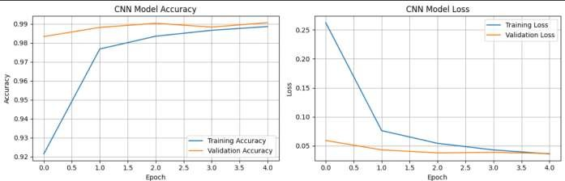
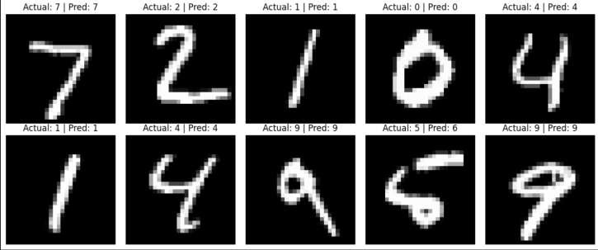

CONFUSION MATRIX:
